**Installing and configuring a web server**

In this document I am going to be configuring an installation of OpenSUSE to run a web server. I will install a LAMP stack then install phpMyAdmin to allow us to add a user and database. I will be using the default terminal application in OpenSUSE (Konsole) to perform most of the installation which can be found by searching for it in the start menu at the bottom left.

First we will run three commands to install apache, start it and set it to automatically start at boot-time. We will use double ampersands (&&) between the commands to make them run consecutively as long as the previous command succeeds. Then we will run another command to check that apache2 is running.

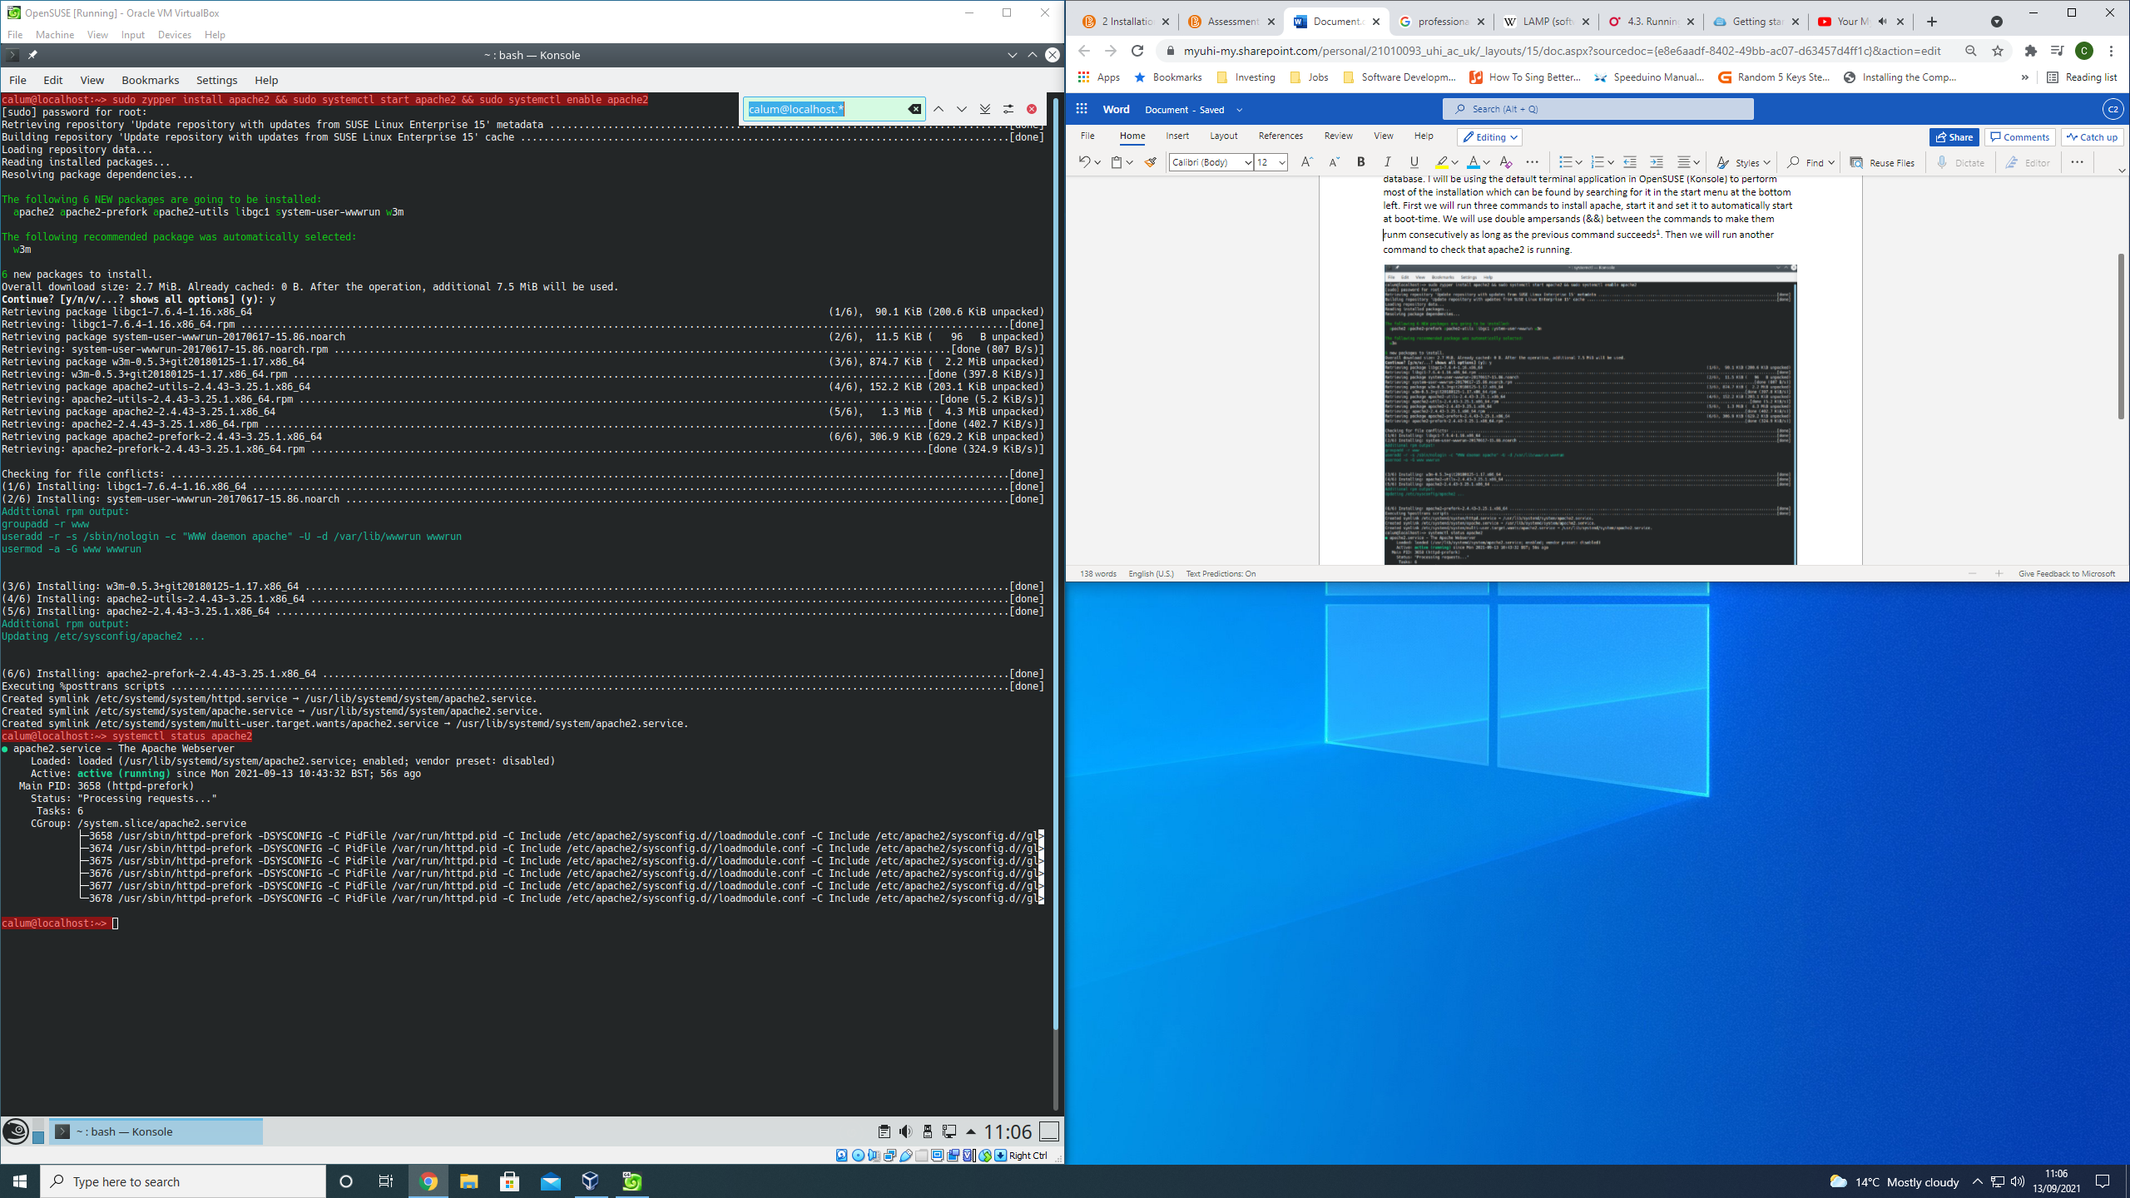

**Commands are highlighted in red**

I will now test the basic operation of the webserver by creating a basic webpage in html and saving it as index.html (the default landing page) to the webserver root path “/srv/www/htdocs/”. I will use Joe’s Own Editor to create/edit documents as it comes preinstalled on OpenSUSE. Finally I will check that the webserver is serving webpages correctly by navigating to localhost or 127.0.0.1 with firefox.

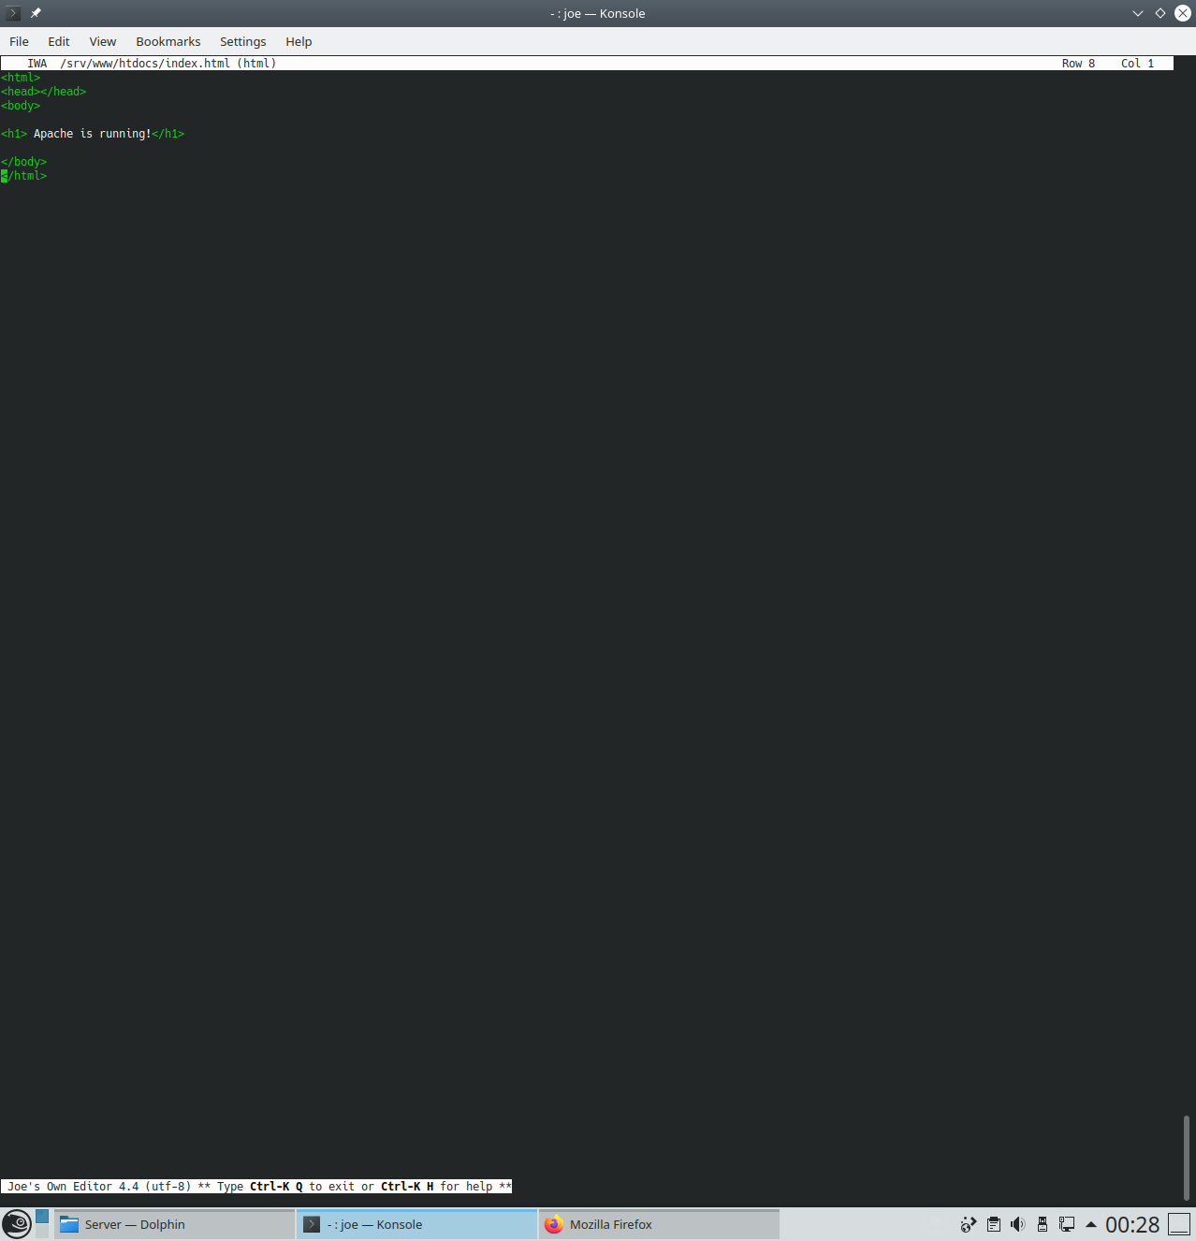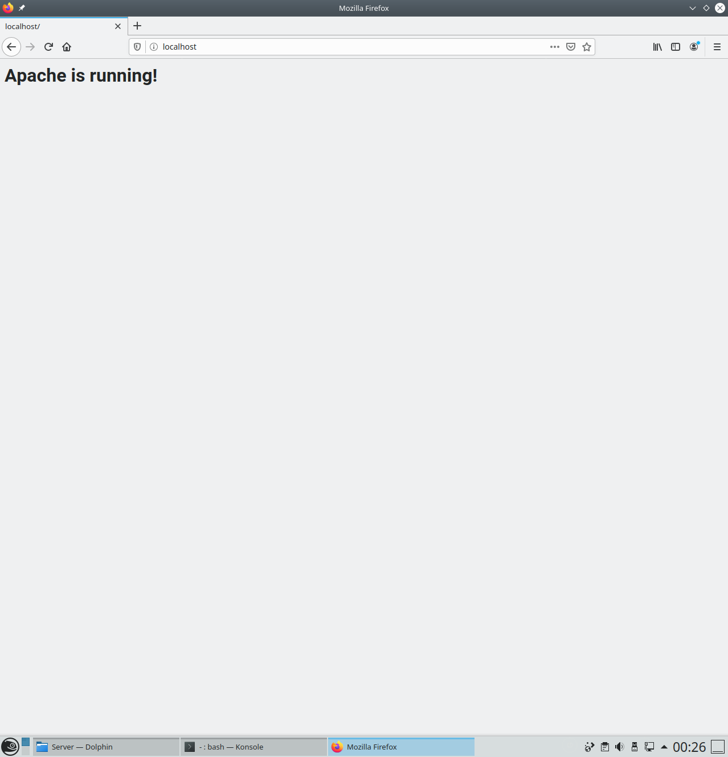

**Success!**

Now we are going to install MariaDB. Similarly to Apache we will use three commands to install, start and start on boot. We will then check the status of the running service to make sure it is running correctly (enabled and active). Finally we will run a shell script to set a root password and otherwise improve the security of the mysql installation.

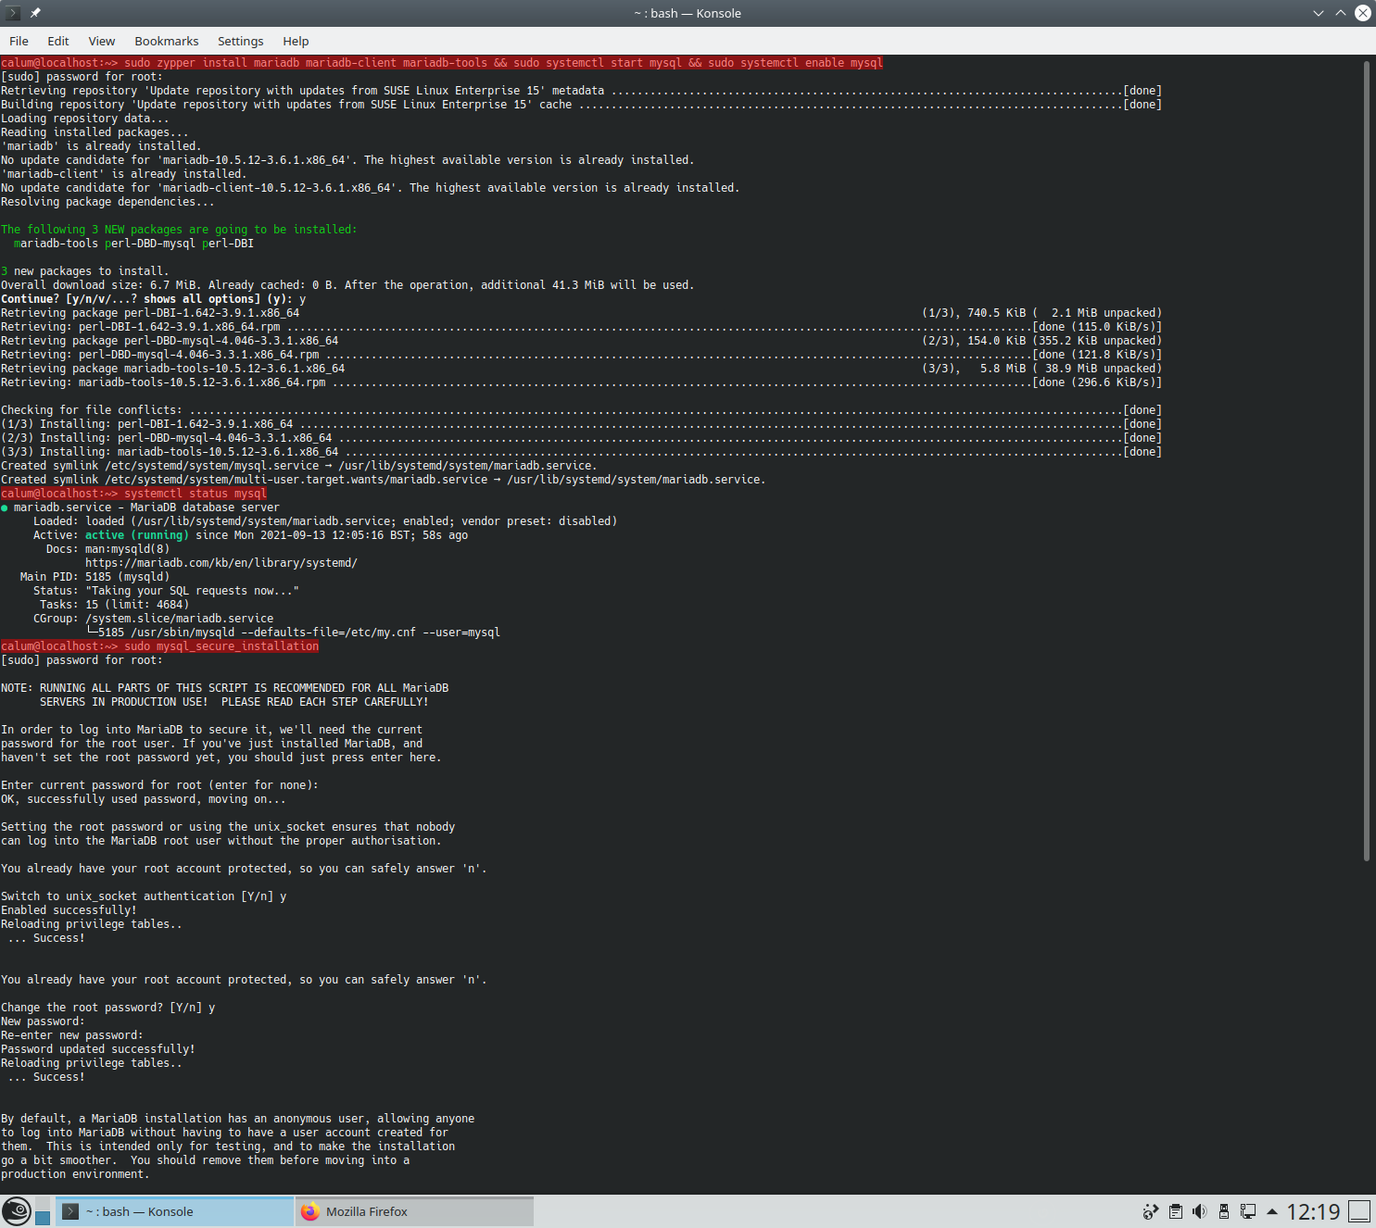

**Commands are highlighted in red**

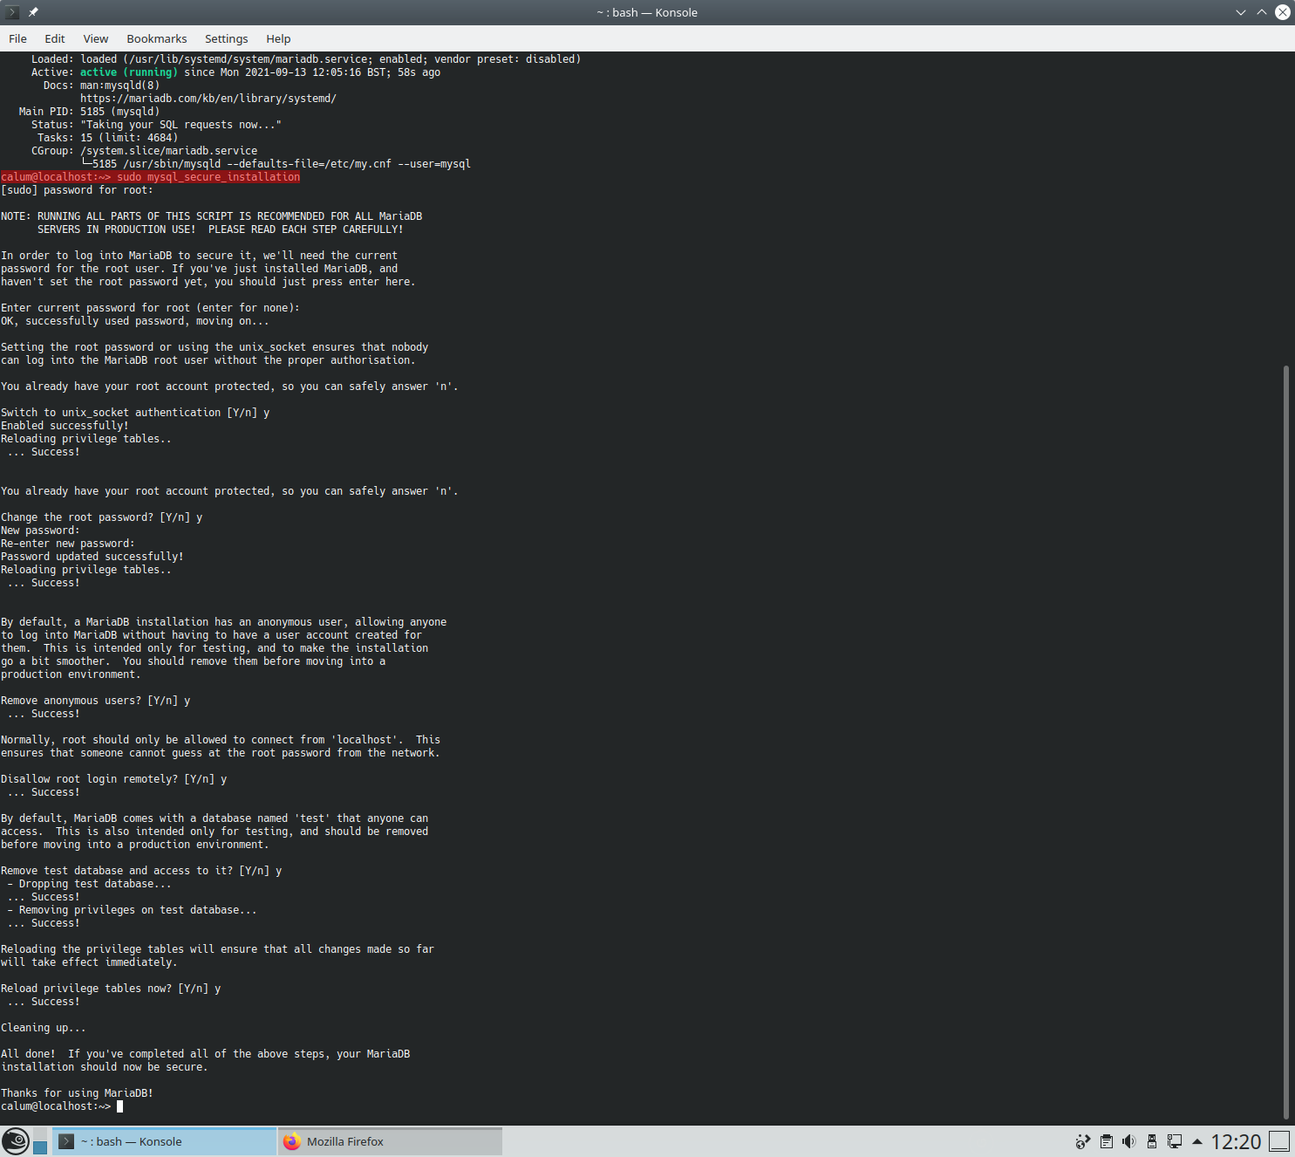

**Commands are highlighted in red**

Next we are going to install PHP7 and a couple of extensions to allow it to integrate with mysql and apache. This is done in much the same way as the two previous sets of packages. We will use three commands to install everything, enable the php7 apache module and restart the apache service. We will then create a test.php file in the webserver root path and navigate to localhost/test.php through firefox to ensure that php has been enabled and is functioning correctly.

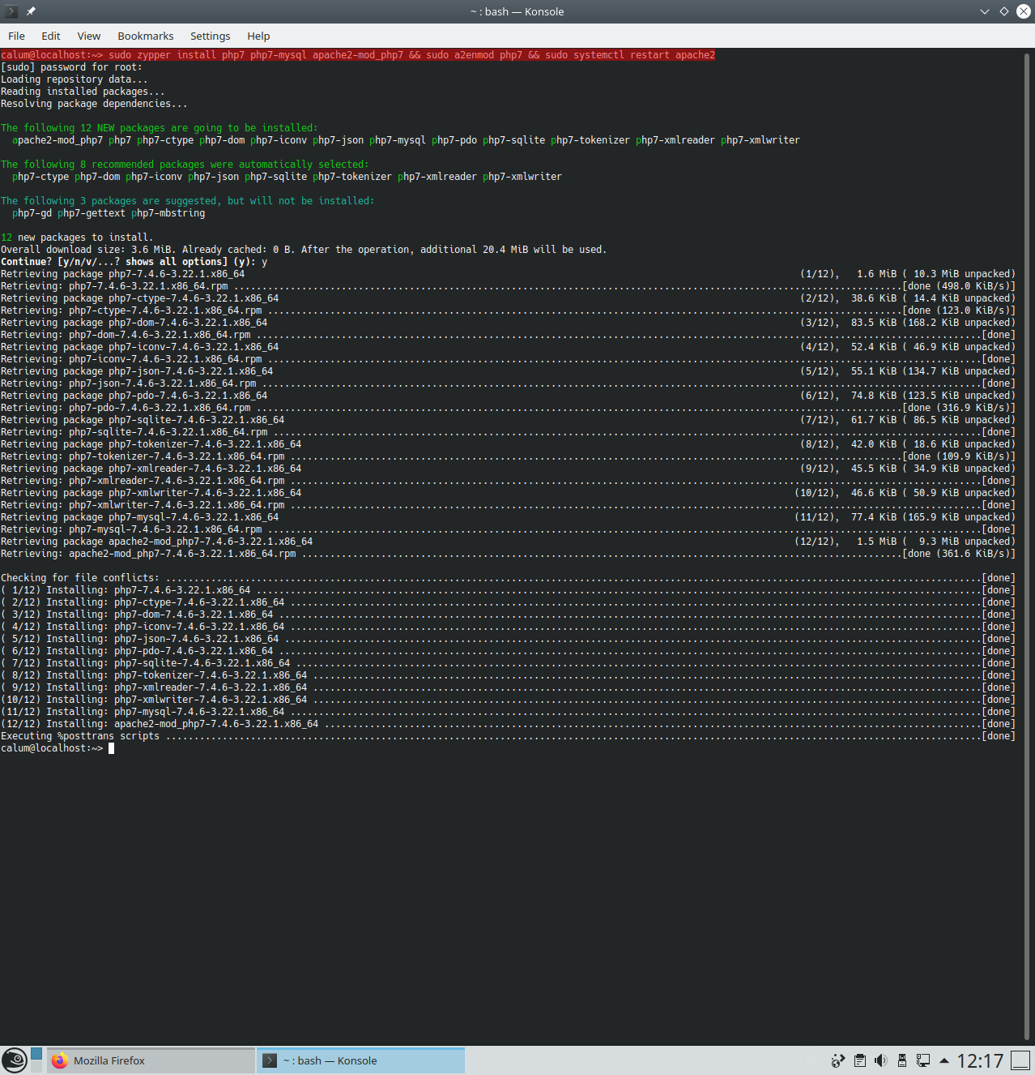**Commands are highlighted in red**

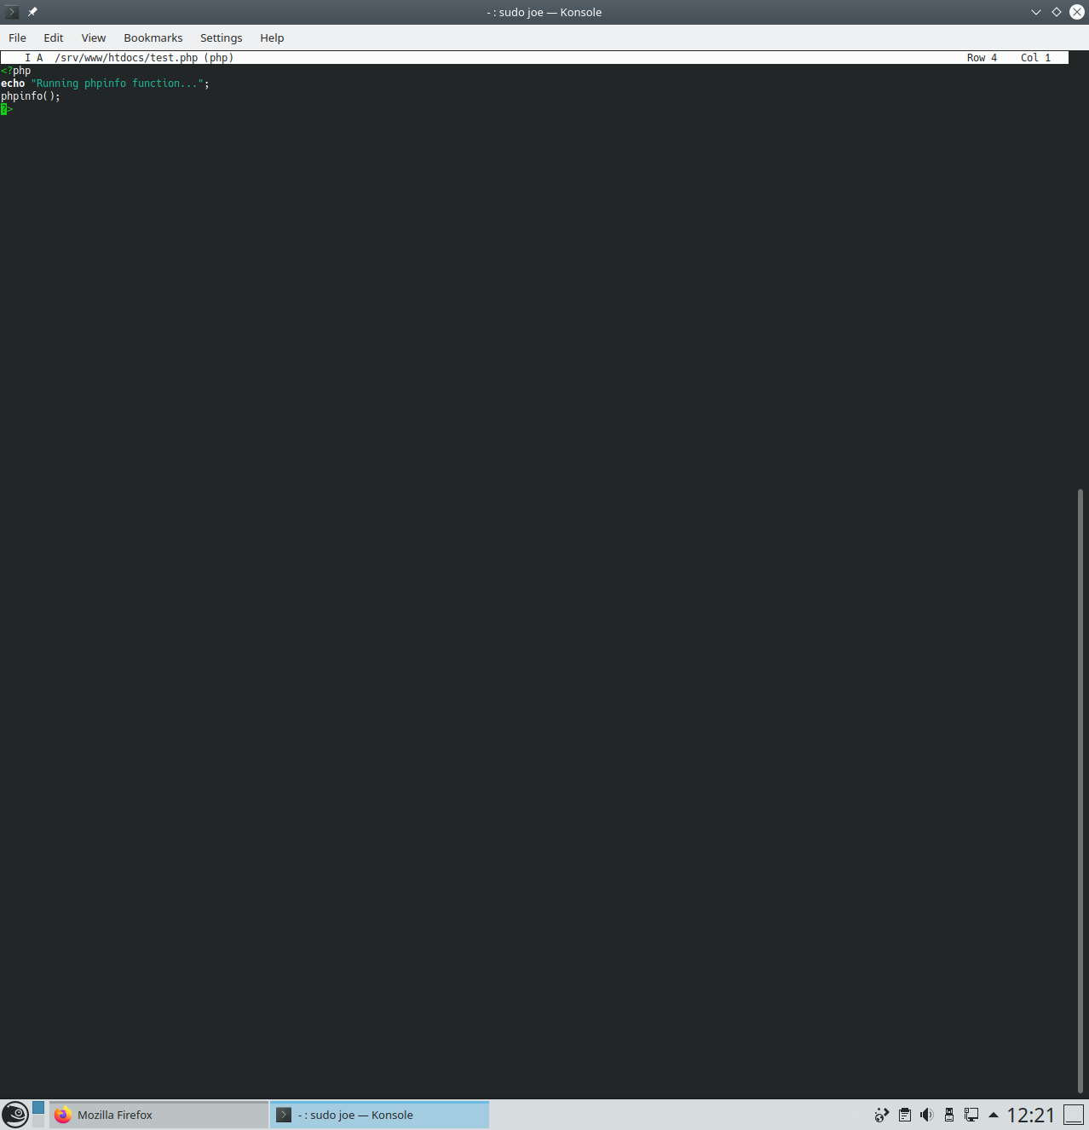

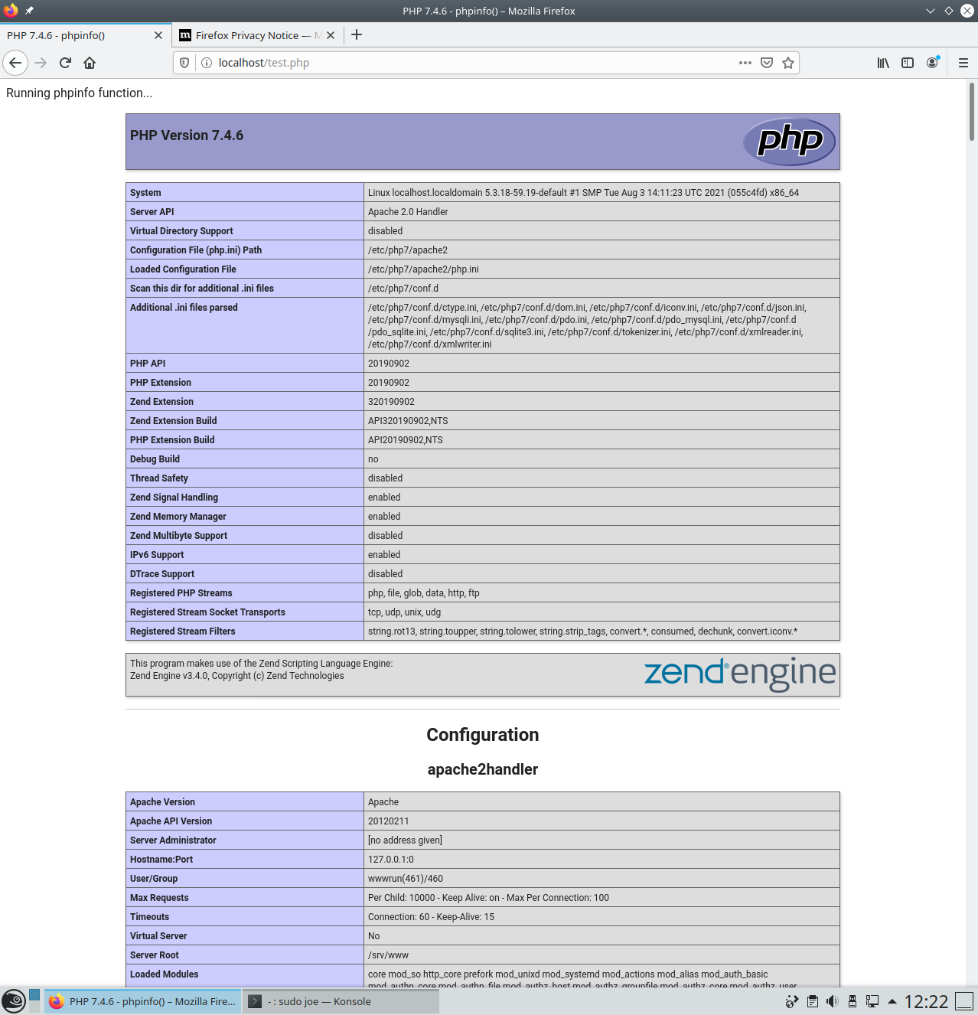

Finally we will install phpMyAdmin, add a database called AtlasDB, a user called AtlasAdmin with the password AtlasPassword! and assign AtlasAdmin permissions to AtlasDB. There are only two commands this time one to install phpMyAdmin and the other to restart apache2 then we can navigate to localhost/phpMyAdmin to add the database, user and permissions. The phpMyAdmin interface is fairly straightforward with the only caveat being that it automatically applies permission globally so you must be careful to only set permissions to the database you want!

